

***DATA ENGINEERING***

***WEEK-02***

***TASK-06***

*Submitted to*

***Sir Muhammad Ahtisham***

*Submitted by*

***Aabra Malik***

***SQL CONSTRAINTS***

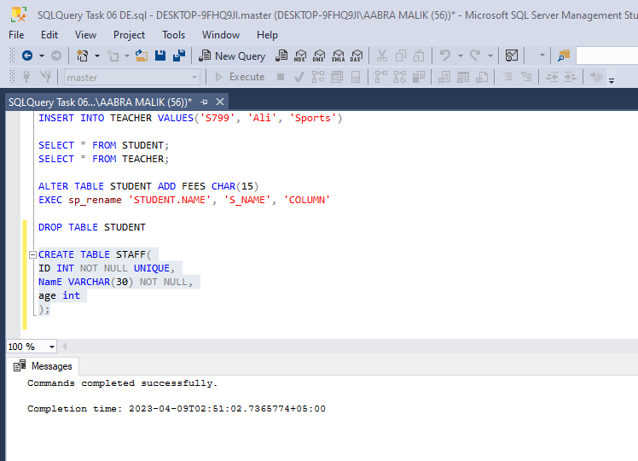

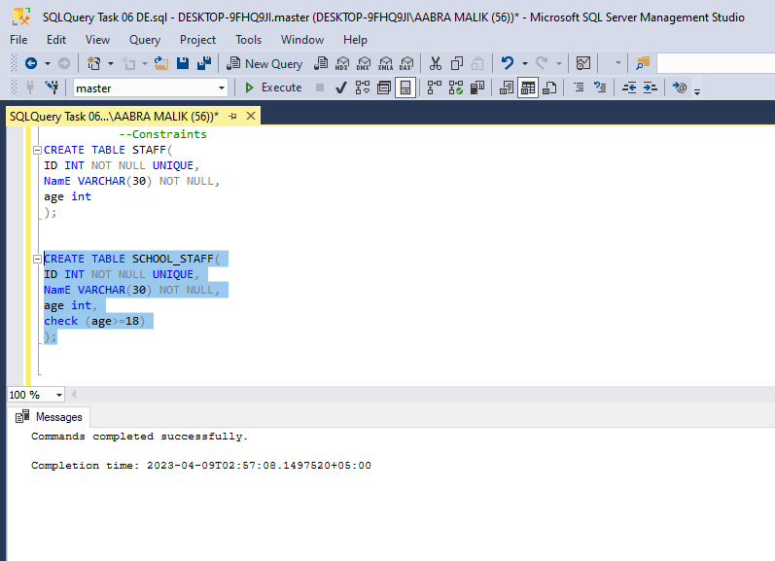

***Creating, Altering & Deleting Tables***

***Creating Database***

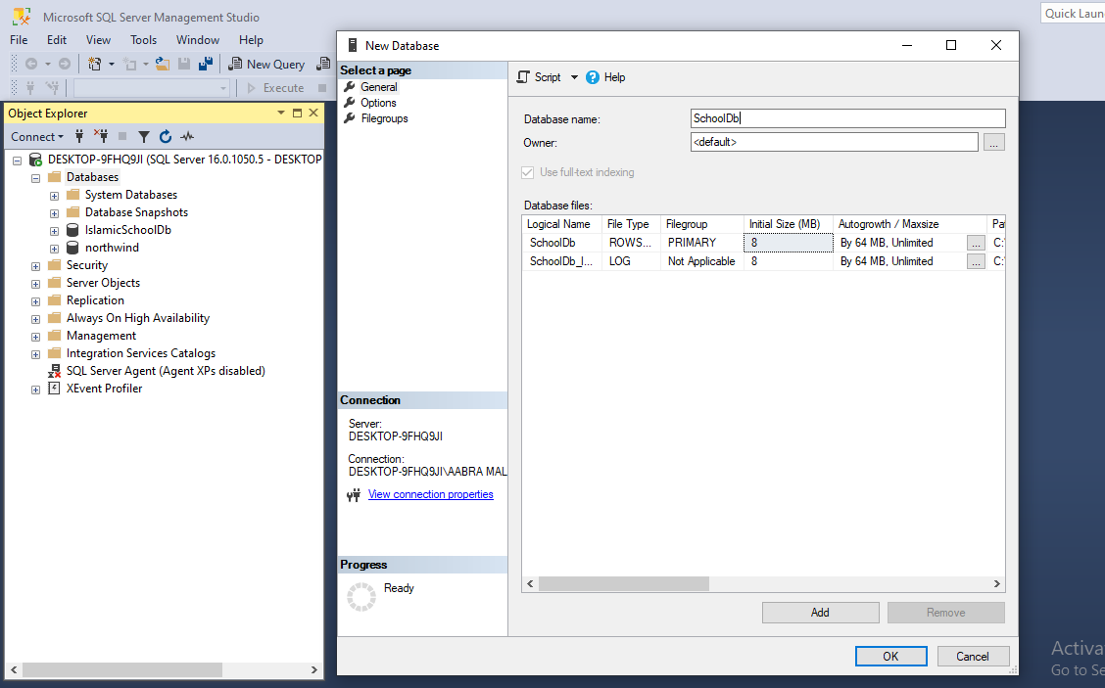

***Creating Student Table***

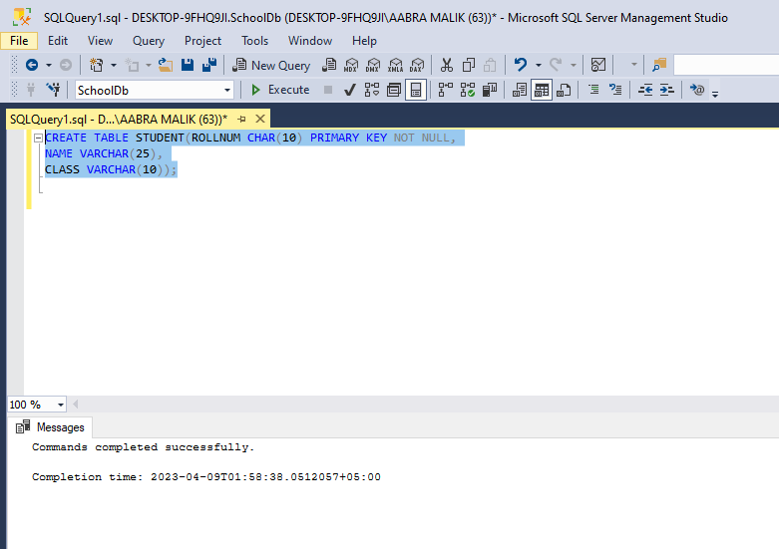

***Creating Teacher Table***

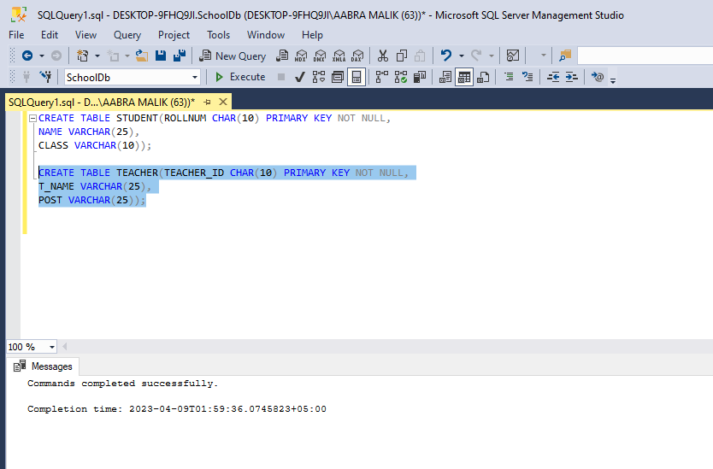

***Inserting rows in Student Table***

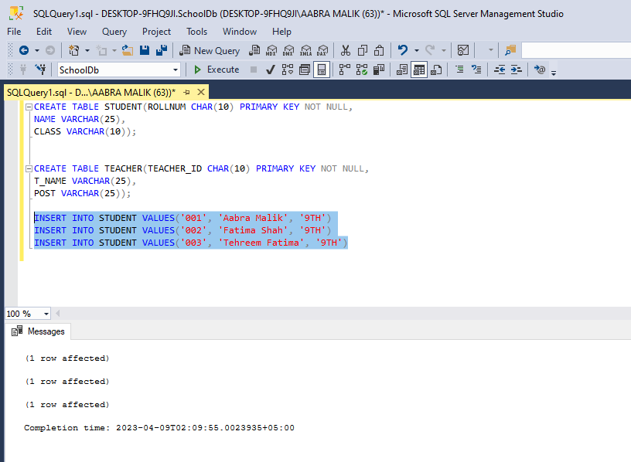

***Inserting rows in Teacher Table***

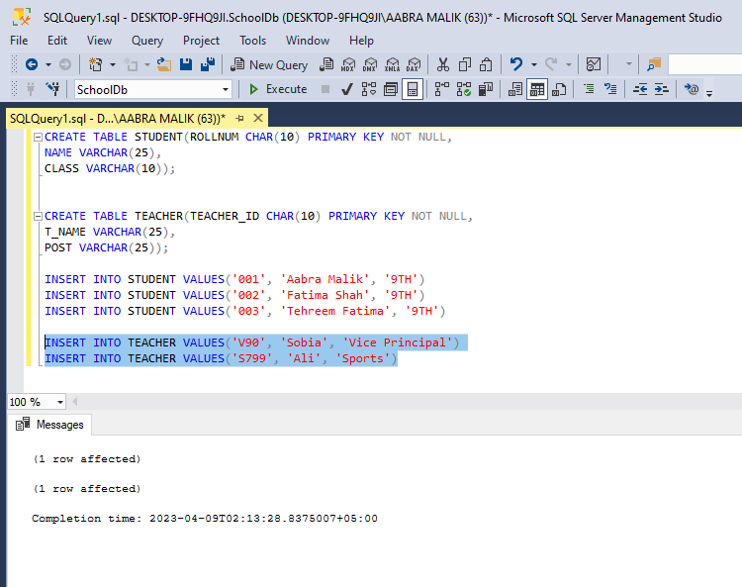

***Viewing Tables***

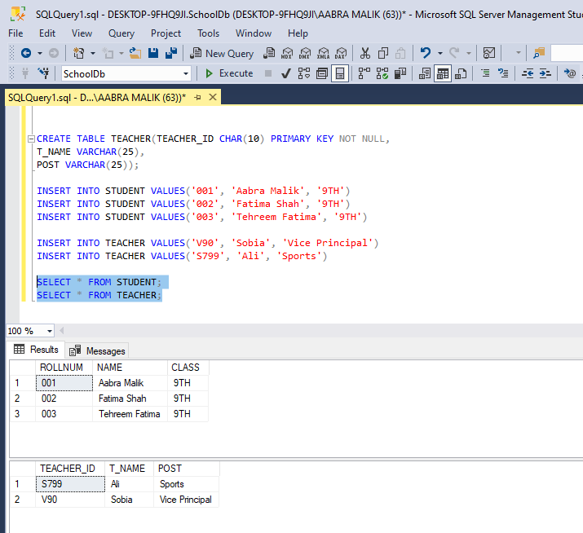

***Altering Student Table***

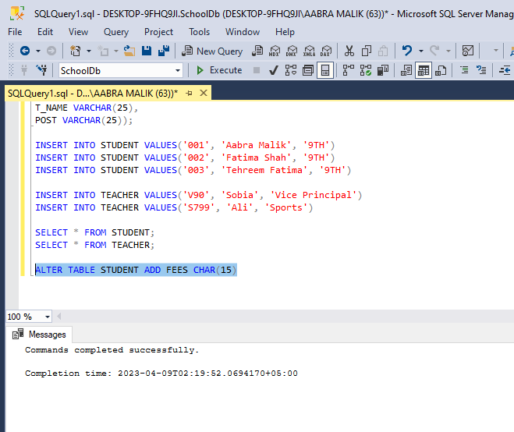

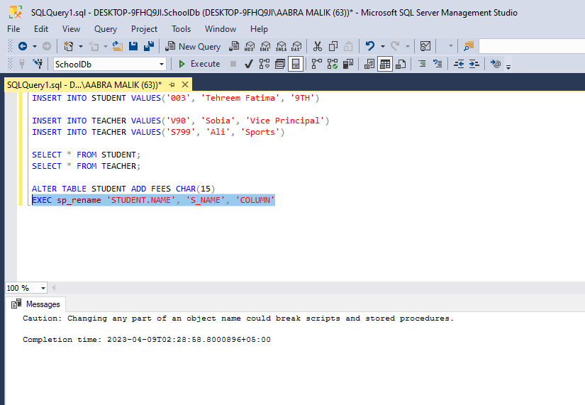

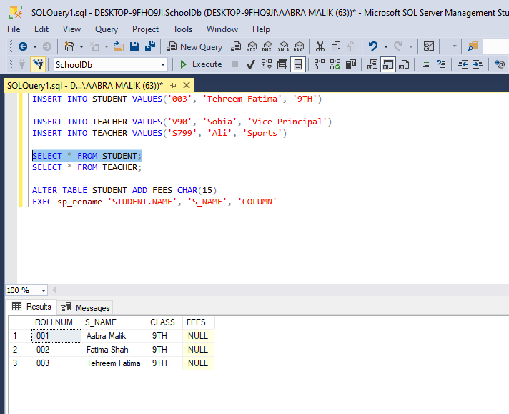

***Deleting Student Table***

